**BA hons degree**

BA Hons or Bachelor of Arts (Honours) in any subject is an undergraduate honours course of 3 years.

The minimum eligibility criteria for any aspirant to pursue this course is to have a 10+2 degree with 55% from any recognized board.

Admission to BA Hons is usually offered through merit but some universities like Delhi University, Symbiosis University and few more conduct their entrance exams for the same.

*****BA Hons : Key Highlights*******

Average Fees: IINR 20,000 to 80,000

Specializations: English, History, Hindi, Sanskrit, Philosophy, Urdu, Sociology, etc.

Popular Jobs:Teacher, Content Writer, Banker, Lawyer,Political Analyst, Journalist,

Communicator, Human Resource Managers etc

Average Salary: INR 4 to 9 LPA

Top Recruiting Areas: Banks, Business Houses, Consultancies, Educational Institutes,, Economic Development, Export Companies, Foreign Affairs, Field Research Firms,, Industrial Houses, Law Firms, Lobbying Firms, Media Houses etc.

Top Companies: Deloitte, ITC Hotels, NIIT, Byju’s, Toppr, BCG, ICICI Bank, HDFC Bank, KPMG, Accenture, etc.

BA Hons Scope: MA, B.Ed, LLB, MBA or Professional Diploma Courses

OVERVIEW

JOBS

SYLLABUS

BA HONS ADMISSION 2021

CUTOFF

BA HONS. COLLEGES

Sakshi Gupta logo

Sakshi Gupta

Content Curator

BA Hons or Bachelor of Arts (Honours) in any subject is an undergraduate honours course of 3 years.

The minimum eligibility criteria for any aspirant to pursue this course is to have a 10+2 degree with 55% from any recognized board.

Note: Students who wish to pursue their education in Management field or get a career boost, can check MBA course.

Admission to BA Hons is usually offered through merit but some universities like Delhi University, Symbiosis University and few more conduct their entrance exams for the same.

BA Hons : Key Highlights

Average Fees: IINR 20,000 to 80,000

Specializations: English, History, Hindi, Sanskrit, Philosophy, Urdu, Sociology, etc.

Popular Jobs:Teacher, Content Writer, Banker, Lawyer,Political Analyst, Journalist, Communicator, Human Resource Managers etc

Average Salary: INR 4 to 9 LPA

Top Recruiting Areas: Banks, Business Houses, Consultancies, Educational Institutes,, Economic Development, Export Companies, Foreign Affairs, Field Research Firms,, Industrial Houses, Law Firms, Lobbying Firms, Media Houses etc.

Top Companies: Deloitte, ITC Hotels, NIIT, Byju’s, Toppr, BCG, ICICI Bank, HDFC Bank, KPMG, Accenture, etc.

BA Hons Scope: MA, B.Ed, LLB, MBA or Professional Diploma Courses

IGNOU, NSOU, etc are some of the colleges offering BA Hons distance education within a range INR 9,500 to INR 15,000.

List of top colleges in india

With there all information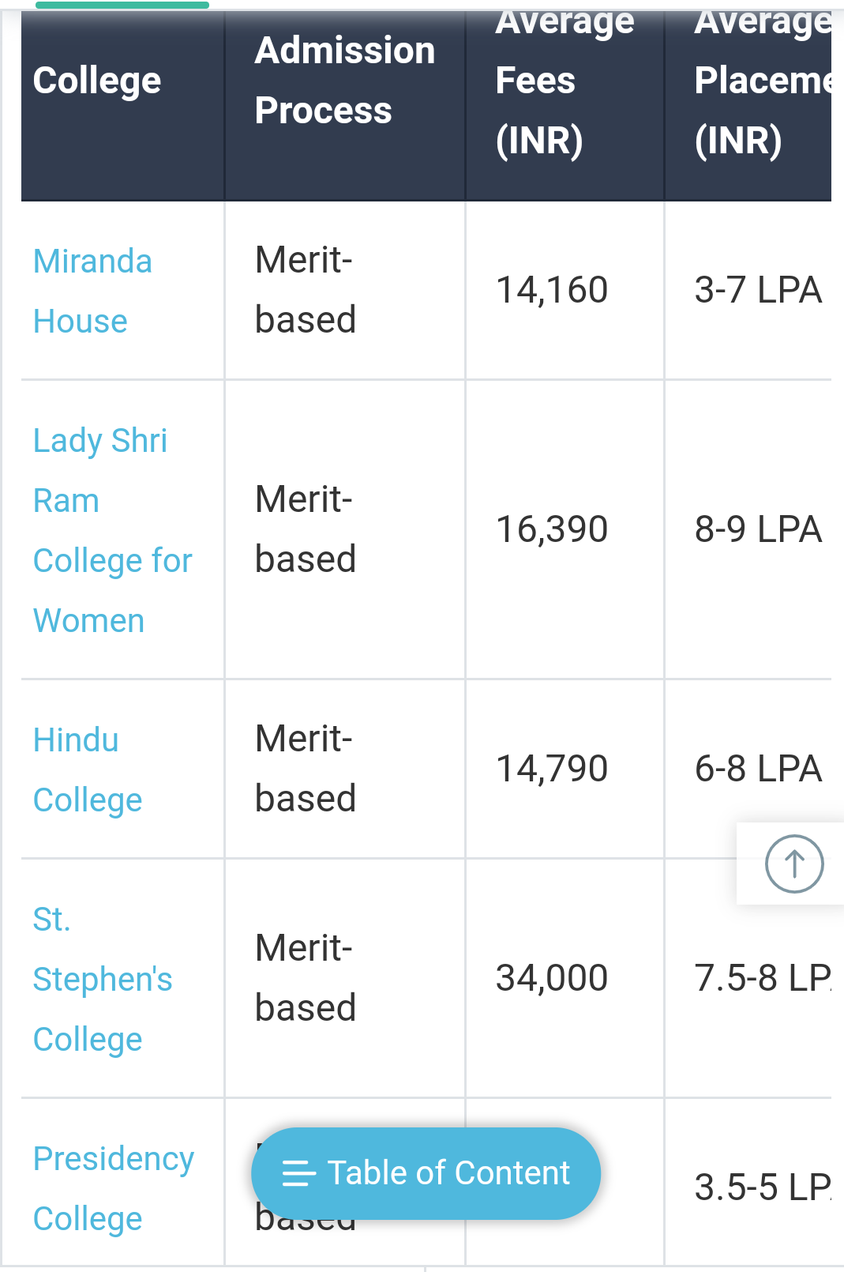

**BA Hons Eligibility**

The eligibility criteria are different for admissions through entrance exams and merit basis, but the basic standards to be followed by the students willing to pursue BA Hons are listed below:

A high secondary level of degree with a minimum percentage of 45% is needed.

In order to get admission to elite colleges like Delhi University, Mumbai University or other prestigious universities, one needs to have more than 90%.

Students may need to go through entrance exams conducted by few universities like Banaras Hindu University, Dayanand Sagar University,etc.

|  |  |  |  |  |
| --- | --- | --- | --- | --- |
| **Exam name** | **Conducting Body** | **Application form** | **Exam dates** | **Exam modes** |
| **DUET** | **Delhi University** |  |  | **Online** |
| **NPAT** | **NMIMS** |  |  | **ONLINE** |
| **BHU-UET** | **Banaras hindu university** |  |  | **Online** |
| **TISS BAT** | **tata institute of social sciences** |  |  | **Paper 1- Online, Paper 2- Offline** |
| **IPU SET** | **Guru Gobind Singh Indraprastha University** |  |  | **Online** |
|  |  |  |  |  |
|  |  |  |  |  |
|  |  |  |  |  |

The eligibility criteria are different for admissions through entrance exams and merit basis, but the basic standards to be followed by the students willing to pursue BA Hons are listed below:

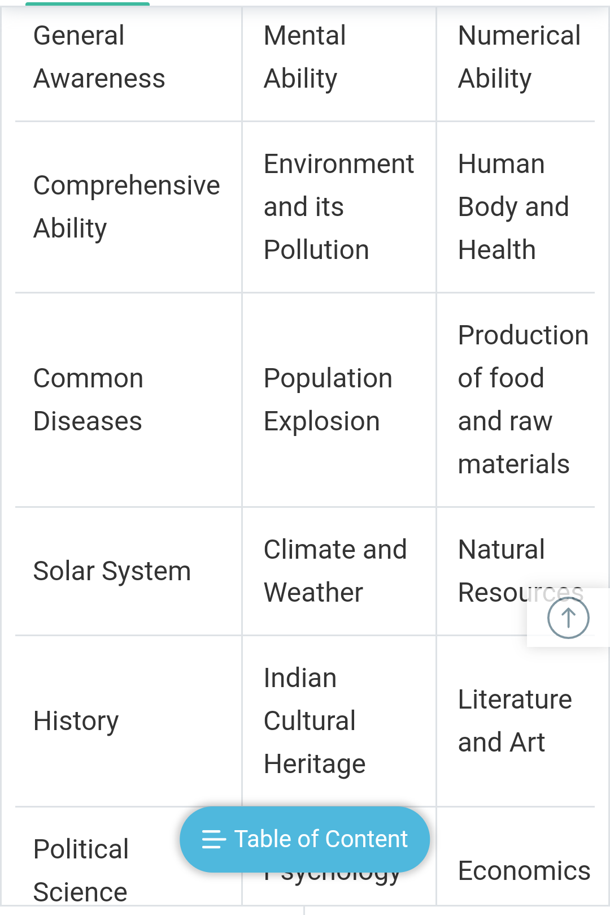

A high secondary level of degree with a minimum percentage of 45% is needed.

In order to get admission to elite colleges like Delhi University, Mumbai University or other prestigious universities, one needs to have more than 90%.

Students may need to go through entrance exams conducted by few universities like Banaras Hindu University, Dayanand Sagar University,etc.

BA Hons Admission Process

BA Hons Admission Process

Admission to BA Hons can be obtained through any of the following mechanisms:

Merit-Based: Most of the colleges like Hindu College, St. Stephens College, etc. offering BA Hons in India follow a merit-based admission process.

Colleges come up with their cut-off lists and one fulfilling the score range mentioned in the list gets through the admission process after completing the entire registration, document updation and fee payment process.

Entrance Exams: In cases of some Universities like University of Delhi, Banaras Hindu University and few more, admission to the course is made on the basis of marks obtained in the entrance exams conducted by the universities.

One needs to register for the entrances and upload documents for the same to become eligible and to get the admit card for the entrances.

Shortlisted candidates after cracking the exams are selected after completing the process of counselling, interview and payment of fees.

BA Hons Admission 2021 will start in May or June 2021. While Delhi University will release the cut off once the 12th class results are announced, many other universities conduct an entrance exam to grant admission to the BA Hons program.

The eligibility criteria are different for merit-based admission and entrance based admission.

Students must have qualified class 12th with at least 55% marks from a recognized board.

To get admission in top colleges like Colleges affiliated to DU, then students must score more than 90% in class 12th.

Colleges offering merit-based BA Hons admission, they release their own cut off lists, candidates who will qualify the cut off can get admission.

Few universities like Delhi University, Banaras Hindu University conduct their own entrance test for BA Hons Admission.

Shortlisted candidates will be called for counselling and personal interview.

Du Cut off 2021 for BA Hons will be high and different for every college under DU.

BA Hons or Bachelor of Arts (Honours) is an undergraduate degree program of 3-years. Candidates can pursue BA Hons in English, Hindi, History, Philosophy, Sanskrit, Sociology, Urdu, etc.

**BA Hons Admission 2021**: National Level Entrance Exams

Few national level entrance exams are conducted for admission to BA Hons course. Some of them are mentioned below:-

**CUCET 2021**

CUCET is the Central University Common Entrance Test which is conducted every year to select candidates into the 13 Central and 5 other participating Universities. It will be a computer based exam on the subject you wish to study. Candidates can choose three Universities among all and select the particular subject.

Colleges Accepting CUCET Score are:-

Central University of Andhra Pradesh

Central University of Gujarat

Central University of Jharkhand

Central University of South Bihar

Eligibility Criteria

Candidates should have a minimum of 50% marks in class 12th for General category candidates and 45% marks for SC/ST candidates.

OVERVIEW

JOBS

SYLLABUS

BA HONS ADMISSION 2021

CUTOFF

BA HONS. COLLEGES

Arunima Sethi logo

Arunima Sethi

Content Curator

BA Hons Admission 2021 will start in May or June 2021. While Delhi University will release the cut off once the 12th class results are announced, many other universities conduct an entrance exam to grant admission to the BA Hons program.

The eligibility criteria are different for merit-based admission and entrance based admission.

Students must have qualified class 12th with at least 55% marks from a recognized board.

To get admission in top colleges like Colleges affiliated to DU, then students must score more than 90% in class 12th.

Colleges offering merit-based BA Hons admission, they release their own cut off lists, candidates who will qualify the cut off can get admission.

Few universities like Delhi University, Banaras Hindu University conduct their own entrance test for BA Hons Admission.

Shortlisted candidates will be called for counselling and personal interview.

Du Cut off 2021 for BA Hons will be high and different for every college under DU.

BA Hons or Bachelor of Arts (Honours) is an undergraduate degree program of 3-years. Candidates can pursue BA Hons in English, Hindi, History, Philosophy, Sanskrit, Sociology, Urdu, etc.

CUCET TISS BAT BHU UET DUET NPAT

BA Hons Admission 2021: Entrance Exam Schedule

BA Hons Admission 2021: Entrance Exam Schedule

Entrance Exam Registration Date Exam Date

CUCET 2021 March 2021 May 2021

TISS BAT 2021 December 2021 April 2021

BHU UET 2021 February to March 2021 April 2021

JNUEE March 2021 May 2021

DUET March 2021 June 2021

NMIMS (NPAT) December 2020 to April 2021 June 2021

English and Foreign Language University (EFLU) December 2020 to January 2021 April 2021

BA Hons Admission 2021: National Level Entrance Exams

BA Hons Admission 2021: National Level Entrance Exams

Few national level entrance exams are conducted for admission to BA Hons course. Some of them are mentioned below:-

CUCET 2021

CUCET is the Central University Common Entrance Test which is conducted every year to select candidates into the 13 Central and 5 other participating Universities. It will be a computer based exam on the subject you wish to study. Candidates can choose three Universities among all and select the particular subject.

Colleges Accepting CUCET Score are:-

Central University of Andhra Pradesh

Central University of Gujarat

Central University of Jharkhand

Central University of South Bihar

Eligibility Criteria

Candidates should have a minimum of 50% marks in class 12th for General category candidates and 45% marks for SC/ST candidates.

Important Date

Registration Dates- March 2021

Exam Dates- May 2021

JNUEE 2021

The Jawaharlal University (JNU) is a premier Central University situated in New Delhi. JNU is often ranked as the best University in the country according to the NIRF rankings. The National Testing Agency (NTA) conducts the yearly entrance exam. The School for Language, Literature and Culture Studies affiliated to JNU offers BA Hons in 10 specializations. They are Arabic, Chinese, French, German, Japanese, Korean, Persian, Pashto, Russian, and Spanish.

Eligibility Criteria

Candidates must be a minimum of 17 years as on 1st October of the year of admission.

There is no maximum age-limit.

The candidate must have a Senior School Certificate (10+2) or equivalent examination with a minimum of 45% marks.

Process of the Entrance Exam

The applicants can register for the exam on the official website. The exam is conducted in online mode.

If you are selected, then you will be called for the document verification and admission